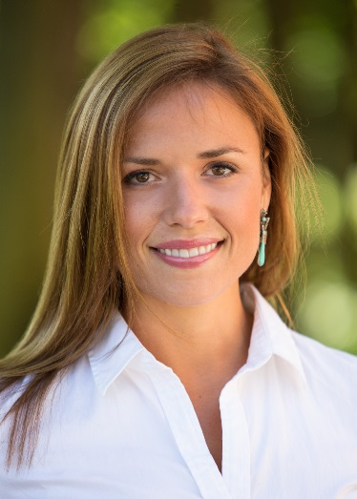
Laura Fox O’Sullivan is the Vice President of Rochester Downtown Development Corporation. After obtaining a Bachelor’s in History of Art and Architecture from the University of Pennsylvania, Laura traveled the world for a year to deepen her understanding of economic development, sustainability practices, and agricultural innovations. After returning to the US, she obtained a Master’s in Urban & Environmental Planning & Policy from Tufts University.

As an urban planner and native Rochestarian, Laura has keen interest in working to facilitate this region’s economic development. She has experience in both academic research as well as commerce, having worked as a research assistant at Tufts, and as an urban planner at Bergmann Associates prior to her appointment as VP of the RDDC. Laura grew up in the food industry and is married to entrepreneur and restaurateur Marty O’Sullivan, founder and owner of Marty’s, catering, food trucks, restaurant, and line of sauces She has an interest in the intersection of food and economic development and is involved with various projects to promote Rochester’s revitalization—especially when it comes to its culinary culture. She has been leading the development of the region’s first kitchen incubator, The Commissary, as its Program Director since its inception in 2016.

